

**MIDDLE EAST TECHNICAL UNIVERSITY**

ELECTRICAL AND ELECTRONICS ENGINEERING DEPARTMENT

EE 462-EE 464 COMMON PROJECT

Design of a SM-PMSM Variable Frequency Drive with MATLAB/Simulink

Berkay UZUN 2263812

Yunus ÇAY 2166148

Table of Contents

1.Introduction 3

2. Part A: Pre-design Stage 3

1. 3

2. 4

3. Part B: Sinusoidal PWM 5

1. 5

2. 9

3. 11

4. Part C: Component Selection 14

5. Part D: About the Project 14

# 1.Introduction

# 2. Part A: Pre-design Stage

## 1.

We can calculate the base speed of the PMSM from the calculation of voltage on MTPA. The base speed equation in d-q coordinates is written as follows:

In addition, Sinusoidal-PWM modulation is applied to the system. This means that the output voltage is half of the DC voltage.

Also, inductances in the d and q axes are equal to each other in SM-PMSM.

Another situation is that in case of MTPA there is only current on the q axis. The current value on the d axis is zero.

Moreover, flux linkage is given as shown below:

So:

The base speed we found above is electrical. A pole pair is required to find the mechanical base speed. The pole pair is found as follows:

The mechanical base speed is found by the equation given below:

There is a gearbox in the system, with a ratio of 8.5. With the help of the following formula, the mechanical shaft speed which is referred to as the vehicle speed is found.

In the project definition, vehicle speed is expected in km/h. Therefore, we must first multiply the velocity we found in rad/s by the radius. Then we have to multiply by 3600/1000.

## 2.

The maximum speed of the motor is given in the project description.

In order to find the maximum electrical frequency applied, we first need to find the mechanical frequency. So we need to find the maximum speed in rad/s.

Now that we have found the maximum speed in rad/s, we can calculate its frequency as shown below:

As is known, the electrical frequency is greater than the mechanical frequency. The ratio between them depends on the pole pair. The electrical frequency is found as shown below:

The frequency modulation ratio should be chosen as an odd value that is not too high to reduce harmonic effects. In electric vehicles, this ratio is usually chosen between 8 and 12.

As a result, choosing this ratio as 11 would be a good choice.

# 3. Part B: Sinusoidal PWM

In this part, we are expected to implement a motor drive using sinusoidal PWM (Sine-PWM), and implement a cascaded speed and current controller using parameters

## 1.

In this section , firstly , we need to calculate the equivalent inertia and the load seen at the electric machine shaft. Also, there is a single speed gear box connected between electric motor and wheels with 8.5 gear ratio.

The equivalent inertia is found as follows :

We know the inertia on the wheel. But this inertia is on the load side. Therefore, we need to transfer this to the electric machine side with the gear ratio. We can do this as follows:

Now we need to calculate the inertia of the vehicle. Since the result we found will be on the load side, we need to transfer it to the electric machine side with the gear ratio.

Since all inertia values are found and transferred to the electric machine side, the equivalent inertia is as follows:

The load characteristics of the vehicle are given in the project description. Here is given as shown below.

However, we need to calculate the load torque seen at the electric machine shaft. So, to obtain load torque expression, we should multiply the expression of the load force by radius.

Figure 1shows the speed, torque and dq current waveforms during the transition from 35km/h to 40km/h speed. The motor torque is the summation of load torque and the torque resulted from the equivalent inertia. The motor torque reaches the nominal torque of the machine during the transition. The limitation is determined with saturation block used for the iq, quadrature axis current. The reason for reaching nominal torque of the machine is usage of step change of speed. If the reference speed were given with ramp function, the motor torque during the transition could be adjusted. The functionality of controller is sufficient. As seen in the Figure 1, the reference speed and the speed of the car matches after the transition period. Moreover, the reference of id current is given as zero since the motor operates in the base speed region. Hence, MTPA is applied.

*** Quadrant motroring mode

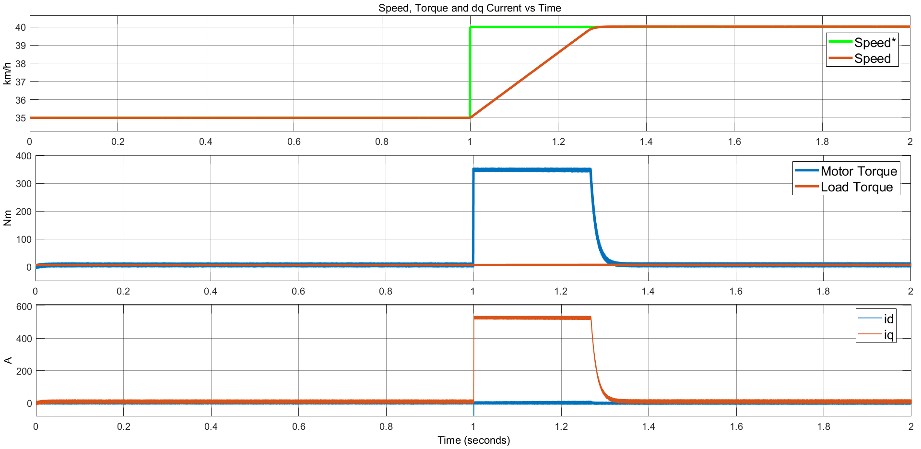

Figure 1 Speed, torque and dq currents waveforms for step change from 35km/h to 40km/h. KP_speed =20, KI_Speed = 0.8.

Figure 2shows also the speed, torque and dq current waveforms during the transition from 35km/h to 40km/h speed. However, the Kp and Ki constants of speed controller are 2 and 0.8, respectively. For the sake of comparison for two different values of proportional constant, the change of Kp constant is applied. According to comparison of Figure 1 and Figure 2, the response time of the system slows down and overshoot is observed for the case in which Kp is 2. As a result, the response time of the system is increased and observed overshoot is eliminated with respect to change of proportional constant, Kp.

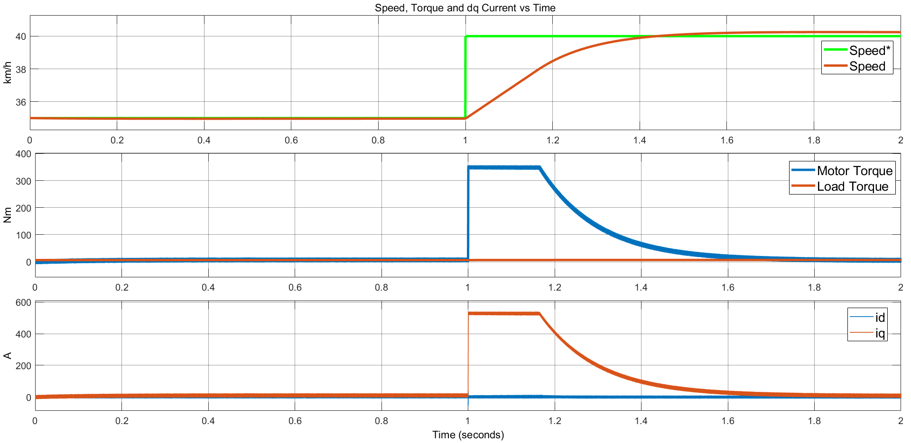

Figure 2 Speed, torque and dq currents waveforms for step change from 35km/h to 40km/h. KP_speed =2, KI_Speed = 0.8.

Figure 3 shows the line-to-line voltage waveforms of the motor. The peak-to-peak voltage value is equal to two times of the Vdc since the voltage measurement is applied between two phases. The peak-to-peak value of the line-to-neutral voltage measurement should be equal to Vdc for the sinusoidal PWM. Since the line-to-line voltage equals to difference of two line-to-neutral voltage, peak-to-peak voltage value of line-to-line measurement is two times of the DC-link voltage. The observed voltage measurements look like having a discrepancy compared to the ideal case. The expected waveforms are shown in Figure 4. However, the observed discrepancy results from the sampling time of the simulation and visual illusion. As seen in the Figure xxx, the density of the PWM signals are very low at the indicated time periods.

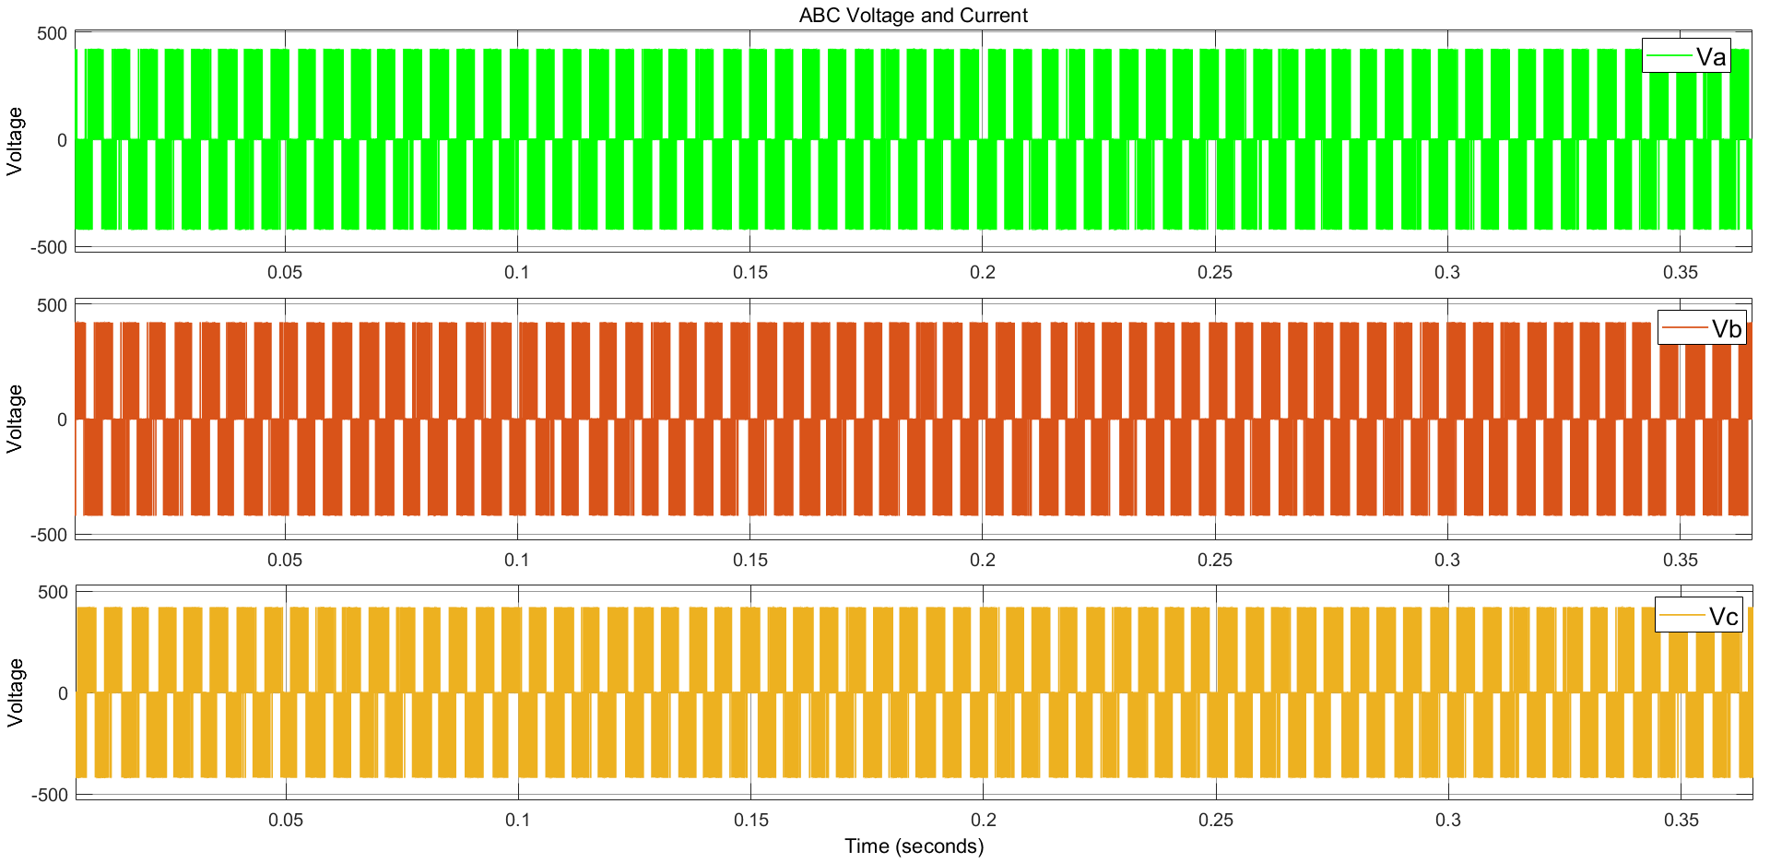

Figure 3 Line-to-line voltage waveforms for step change from 35km/h to 40km/h. KP_speed =20, KI_Speed = 0.8.

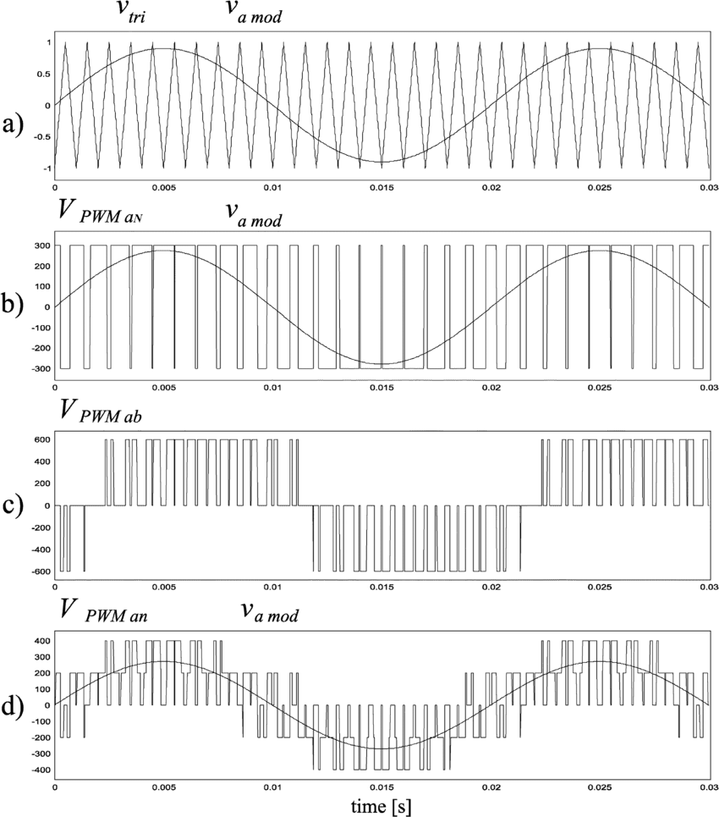

Figure 4 Example line-to-line and line-to-neutral voltage waveforms for sinusoidal PWM

Figure 5 shows the phase currents of the motor during the transition from 35km/h to 40 km/h. The increase in the current at time which equals to 1 second results from the inertia since the step change of speed is applied at that time. The maximum value of the phase current is equal to maximum value of quadrature current due to the amplitude invariant transformation.

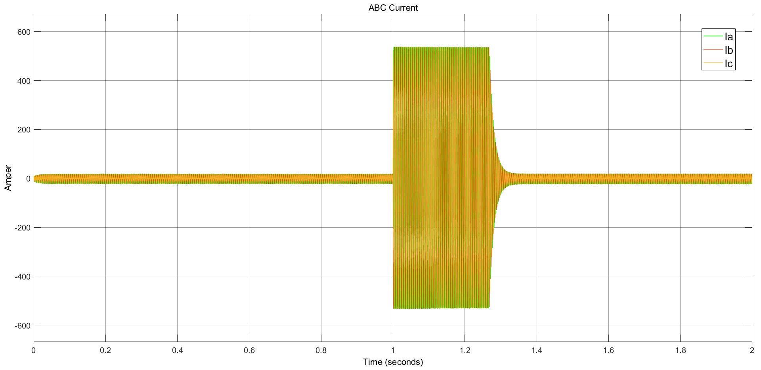

Figure 5 Phase current waveforms for step change from 35km/h to 40km/h. KP_speed =20, KI_Speed = 0.8.

Figure xxx, shows the phase current of motor in magnified view in order to show the sinusoidal shape of the phase currents.

## 2.

Figure 6 shows the speed, torque and dq current waveforms during the transition from 40km/h to -8km/h speed. Firstly, the machine works in motoring mode up to the time in which step change of speed is applied. When the step change of speed is applied the quadrature current diminished to positive value to -530A, nominal current, which implies the machine works in the generating or braking mode. The machine speed is positive and the torque is negative as implied from the iq current in the 2nd current. In other words, applied voltage is positive and applied current is negative, which implies that the power is dissipated to supplied to the grid. When the speed of the motor is equal to zero, the sequence of phase voltage changes and machine starts to work in reverse motoring mode. The operating modes of the machine for the step change from 40km/h to -8km/h can be seen in Figure 7.

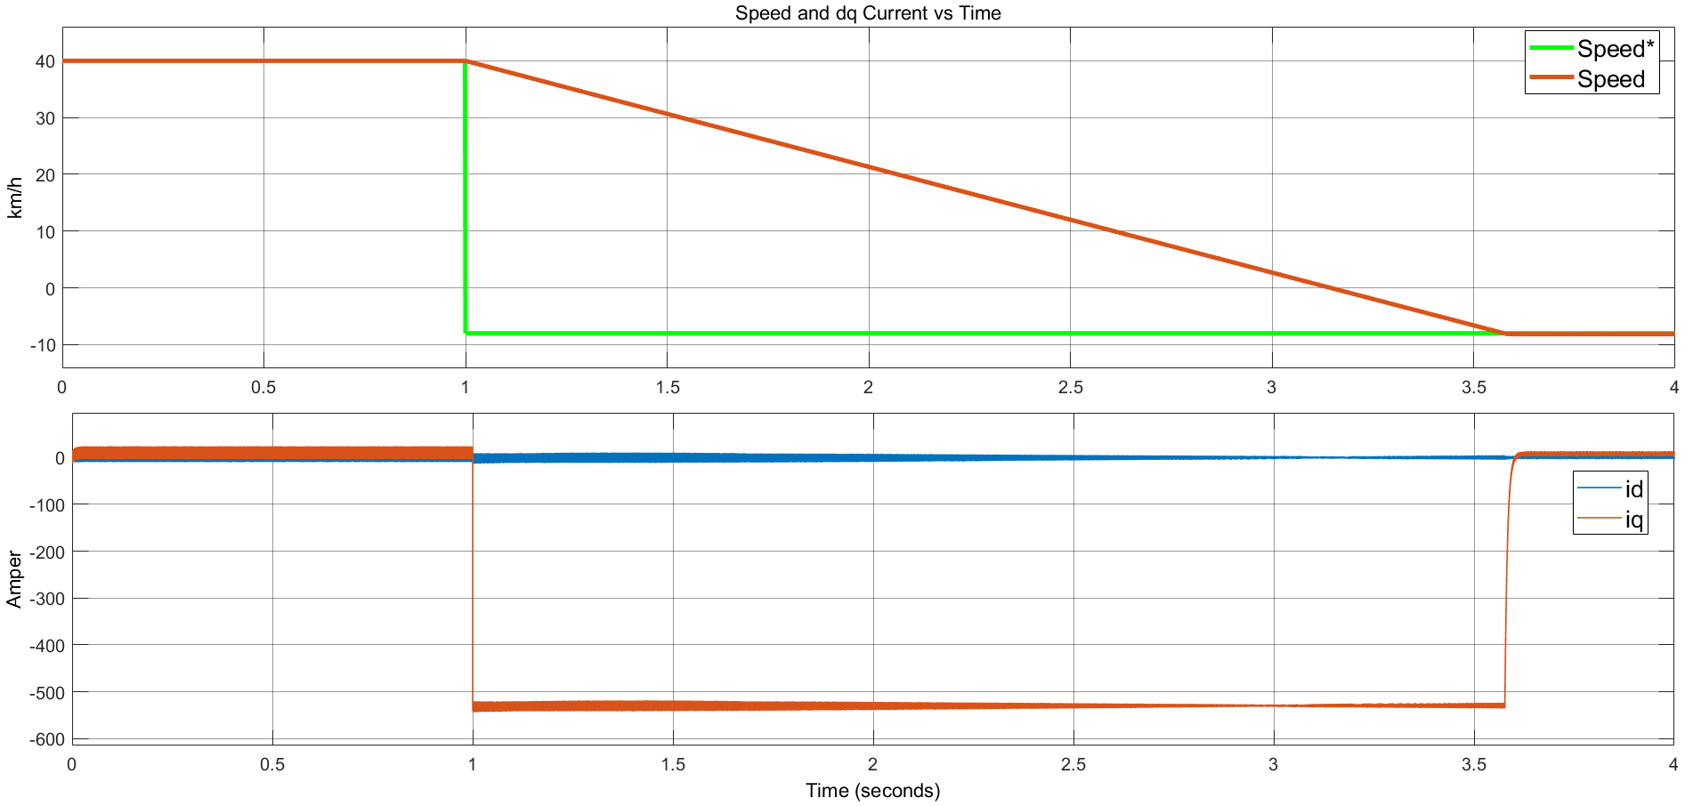

Figure 6 Speed, and dq currents waveforms for step change from 40km/h to -8km/h. KP_speed =40, KI_Speed = 0.1.

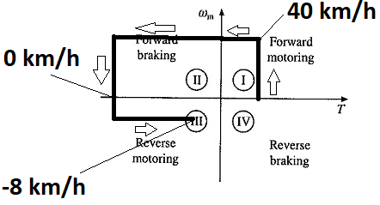

Figure 7 Operating modes of the machine for the step change from 40 km/h to -8 km/h.

Figure 8 also shows the speed and dq current waveforms during the transition from 40km/h to -8km/h speed. However, the Kp and Ki constants of speed controller are 20 and 0.8, respectively. For the sake of comparison for two different values of proportional constant and integrative constant, the change of Kp and Ki constants is applied. According to comparison of and Figure 6 and Figure 8, the response time of the system slows down, and overshoot is observed for the case in which Kp is 20 and Ki is 0.8. The elimination of the overshoot is succeeded with increase in Kp from 20 to 40 and decrease in Ki from 0.8 to 0.1. While increase in the proportional constant makes the system more responsive, decrease in the integrative constant eliminates the error coming from the summation of error between reference speed and measured speed.

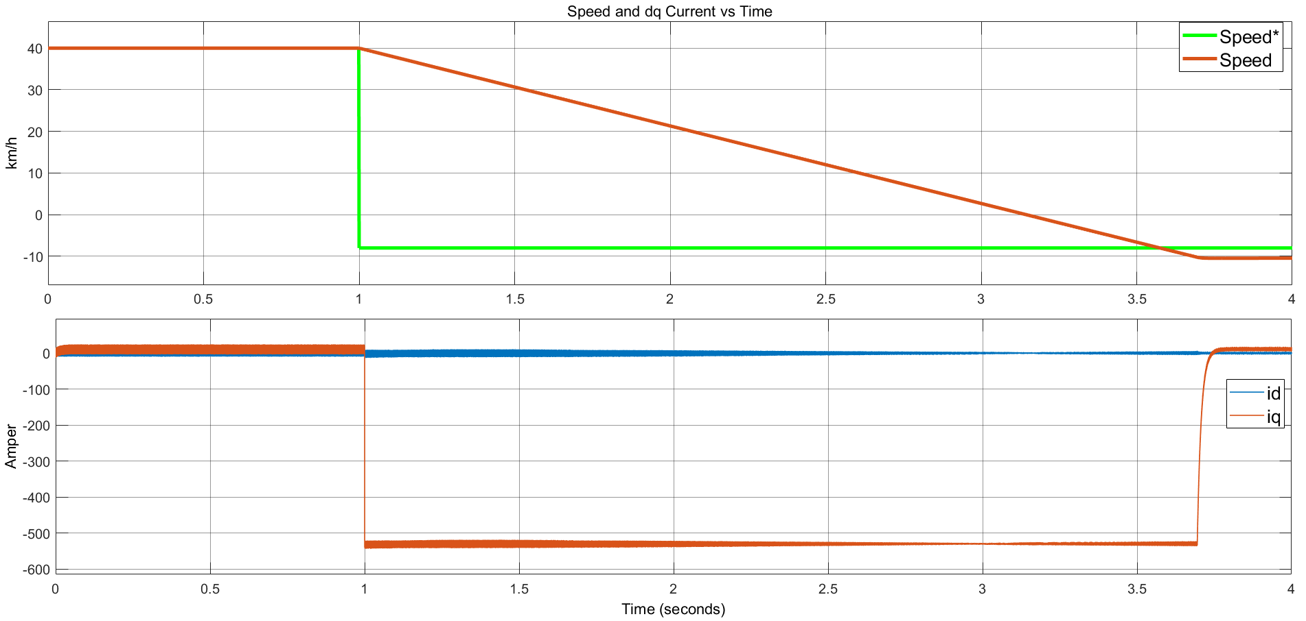

Figure 8 Speed, and dq currents waveforms for step change from 40km/h to -8km/h. KP_speed =20, KI_Speed = 0.8.

Figure 9, shows the phase currents of the motor during the transition from 40km/h to -8km/h. The applied step change in speed at t equals to 1 cause that the quadrature current becomes negative nominal current. The negative iq current and positive speed indicates that the braking is applied, which can be also seen by the density of the sinusoidal in Figure 9. As the motor slows down, the period of the phase current increases. When the speed equals to 0, the sequence of phase currents is flipped, and motor rotates in the negative direction. Hence, the machine starts to operate in reverse motoring region. Then, when the motor reaches to -8km/h, the torque due to the inertia becomes zero and the motor torque decreases the 5.355 Nm.

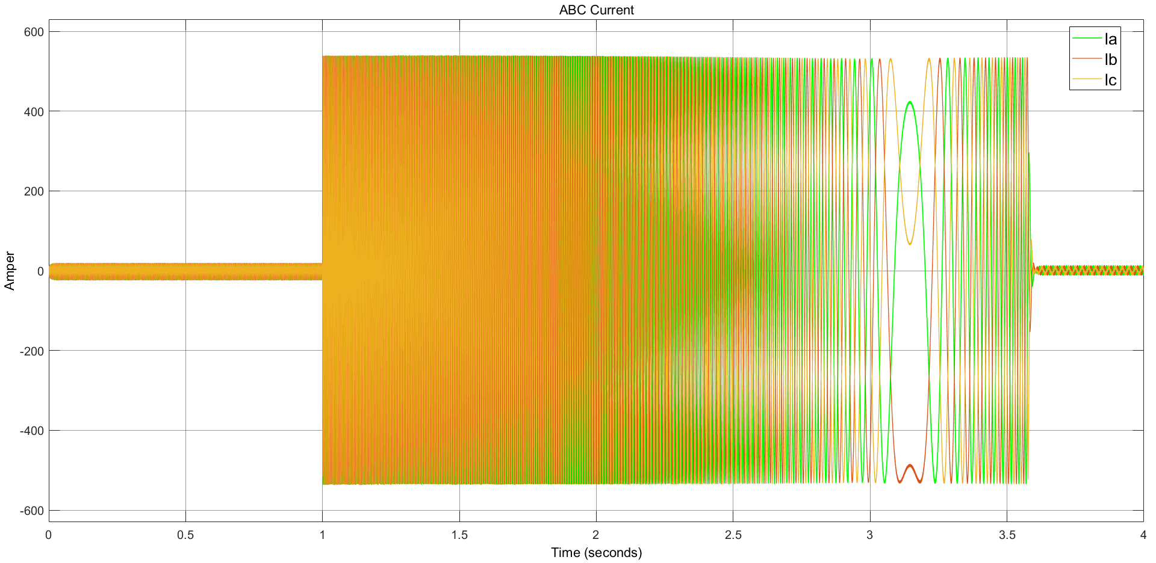

Figure 9 Phase current waveforms for step change from 40km/h to -8km/h. KP_speed =40, KI_Speed = 0.1

## 3.

In this part, first of all, we need to find out in which region our electric motor operates. First of all, we need to find the speed of the vehicle in rad/s and compare it with the base speed. In this way, we can determine in which region it works. If the speed of the vehicle is higher than the base speed, it means that it is operating in the field weakening region. If it is lower than the base speed, it means that it is working in the base speed region. Firstly, we need to convert the speed given in km/h to rad/s.

Now we need to transfer the speed we found to the motor side with the gear ratio.

We previously calculated the base speed. The base speed we found is 342.857 rad/s. We found the speed of the motor as 472.26 rad/s. As it can be understood from here, the speed of the motor is higher than the base speed. Obviously motor is operating in a field weakening region.

Also, we can find by multiplying by the pole pair:

In other words, considering the given conditions, the engine must operate in the field weakening region in order for the vehicle to drive at 60 km/h. It will not be enough to apply only current for the vehicle to drive at this speed. That's why we need to apply current to the system. Since the current is 0 in the base speed region, the vehicle will not be able to reach this speed. As a result, the motor operates in the field weakening region and by applying current along with the current in this region, we ensure that the vehicle drives at the given speed. As a result of this analysis we have done, we need to find and currents. As it is known, the vehicle here is driving at half of the rated torque. So the current will also be halved. current is as shown below.

We can also find the current with the formula given below:

Considering the above analysis results and conditions, we apply 265 A as current and current in the opposite direction to the motor operating in the field weakening region, so that the vehicle can drive at the desired speed.

Figure 10 shows the proposed method for the speed transition from 40km/h to 60km/h without exceeding rated currents. Conceptually, we propose a method how to apply the calculated id* and how to adjust limitation on the iq*. The above f(u) block provides the switch with calculated id current based on the phase limit equation. Then, if the calculated id is negative, switch output gives calculated id*. If not, switch gives zero as a reference. The below switch may be trivial, but it placed to make it understandable. Function of the below switch is determination of whether the speed is above or under the base speed. If above, the output of the above switch is given as id*. If not, id* becomes zero. The bottom f(u) block determines the maximum iq* with respect to calculated nominal current. For instance, if the id* equals to zero, the limit of iq* is equal to nominal current, 530A.

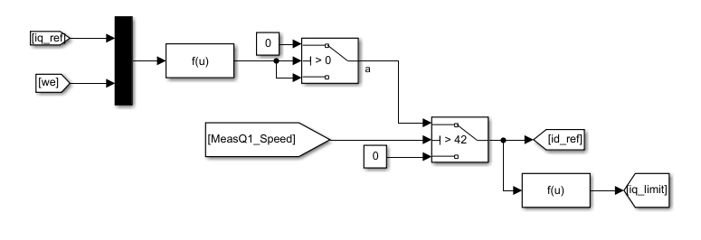

Figure 10 Simulink blocks for closed-loop control of speed transition from 40km/h to 60km/h with field-weakening

Figure 11 shows how the calculated iq_limit is applied to saturation block.

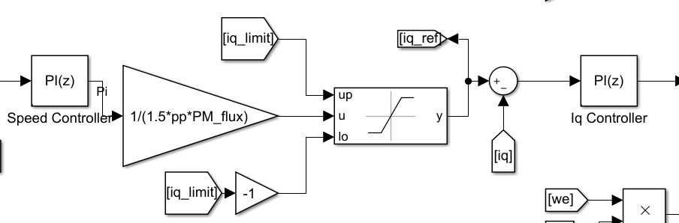

Figure 11 The method for applying iq_limit to saturation block of iq.

Figure 12 shows the speed and dq current waveforms for the step change of 40km/h to 60km/h at the half of the rated torque, 175Nm. As expected, apply of negative id current is a must not to apply over-modulation. When the step change is applied at time equals to 1, the id* current is still given as zero. However, the id* is given as negative after the speed of 47.5km/h. Isn’t it interesting? The base speed is calculated as 43.2km/h, which is valid for the case in which nominal torque is applied. However, the applied torque is half of the rated torque for this question. Therefore, there is no power limitatio

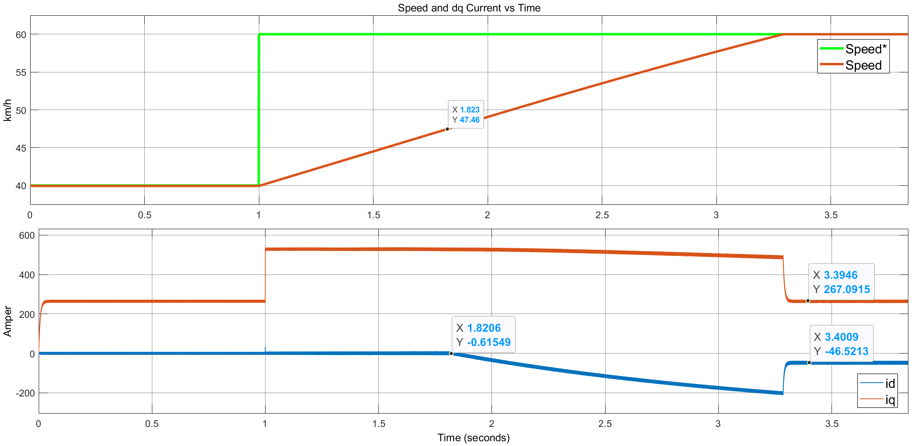

Figure 12 Speed and dq current waveforms for the step change of 40km/h to 60km/h at the half of the rated torque.

# 4. Part C: Component Selection

# 5. Part D: About the Project